**GUÍA DE AUTOAPRENDIZAJE**

|  |  |  |  |
| --- | --- | --- | --- |
| **Sector/ Subsector de aprendizaje/ Especialidad** | Inglés | **Curso:** | III A III B  III C |
| **Objetivo de Aprendizaje** | Reforzar los aprendizajes ligados a las evaluaciones diagnósticas en cada una de las asignaturas/módulos, los cuales son la base para iniciar las unidades de aprendizaje correspondientes a las asignaturas y especialidades. | | |
| **Contenidos** | There is / There are  Cuantificadores: (many, much,***some*, *any*, *no*, *none*, *a lot of*,  *plenty of, few*, *little*, *enough*, *too*, *too many*, *too much)*** | | |

Materiales: Lápiz mina, goma de borrar, diccionario (opcional).

**I.- There is / There are**

Estas expresiones se utilizan para expresar la cantidad de objetos o personas que se encuentran en un determinado lugar. Ambas formas significan "Hay". La diferencia es que la primera se utiliza para el singular y la segunda para el plural

La forma negativa se compone de **There is**o **There are**seguido de **NOT**, y es frecuente encontrar la forma contraída **There isn't**o **There aren't**.

**There isn't a chair in the bedroom. (**No hay una silla en el dormitorio)  
**There aren't two chairs in the bedroom. (**No hay dos sillas en el dormitorio)

EXAMPLES: EXAMPLES:

There is a lemon / a house. There are some chips / trees.

There is + singular

There are + plural

-------------------------------

There is a/an + singular countable

There is some + uncountable

There are some + countable plural

There are two + countable plural

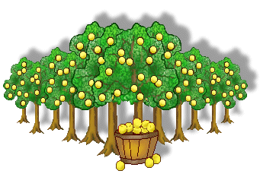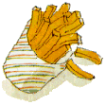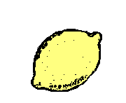

There is an onion / an airport. There are two apples / boys.

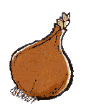[](javascript:edit(71000))

------------------------------------------------------------------------------------------------------------------------

There isn’t + singular

There aren’t + plural

-------------------------

There isn’t a/an + singular countable

There isn’t any+ uncountable

There aren’t any + countable plural

There are two…

There isn’t a banana. There aren’t any grapes.

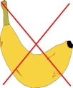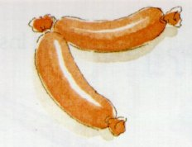

There isn’t any coffee. There aren’t three sausages.

Is there a glass of water? Are there any biscuits?

Is there + singular?

Are there + plural?

How many + plural + are there?

-------------------------

Is there a / an / any …?

Yes, there is. No, there isn’t.

Are there any …?

Yes, there are . No, there aren’t.

Yes, there is. Yes, there are (some).

?



✓



?

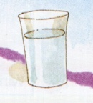

✓

?

?



Is there any tea? How many bottles

are there?

No, there isn’t. There are two.

Exercises (There is / There are)

I.- Transform these sentences into singular or plural: (Transforme estas oraciones en singular o plural)

1. There is a biscuit. =>
2. There is an apple. =>
3. There are some potatoes. =>
4. There are some plates. =>

II. - Change these sentences into negative: (Cambie las siguientes oraciones a negativas)

1. There is a jar of cookies on the table. =>
2. There are some lollipops. =>
3. There are four strawberries in the bowl. =>
4. There is an orange on the plate. =>
5. There is some juice in the glass. =>

III.- Put the words in order to make sentences: (Ponga las palabras en orden y haga oraciones)

1. is / some / there / the / bread / in / basket. =>
2. any / there / biscuits / are / ? =>
3. many / there / lemons / how / are / ? =>
4. isn’t / water / there / any / bottle / the / in. =>
5. spaghetti / any / there / in / isn’t / bowl / the. =>

IV. - Write *is / isn't / are / aren't* in the spaces: (Escriba is */ isn't / are / aren't* en los espacios)

1. ________ there any fruit in the bowl?
2. ________ there any clean plates on the table?
3. There ________ olives in the pizza.
4. There ________ any potatoes on his plate.
5. There ________ some meat in the fridge.
6. There ________ any milk in the jug.
7. There ________ two glasses on the table.
8. How many forks _______ there?

V. - Look at the picture and answer these questions:



1. - Are there any apples?

_________________________________________________________________________

2. - Are there any plates? _______________________________________________________________________

3. - Is there any bread? _______________________________________________________________________

4. - How many pears are there?

_______________________________________________________________________

5. - How many bottles are there?

_________________________________________________________________________

**II.-Quantifiers**

Los**cuantificadores en inglés**(many, much,***some*, *any*, *no*, *none*, *a lot of*,  *plenty of*, *few*, *little*, *enough*, *too*, *too many*, *too much***, etc.) **son palabras que nos ayudan a cuantificar qué cantidad tenemos de algo (mucho, poco, montones, suficiente, demasiado, etc.)**

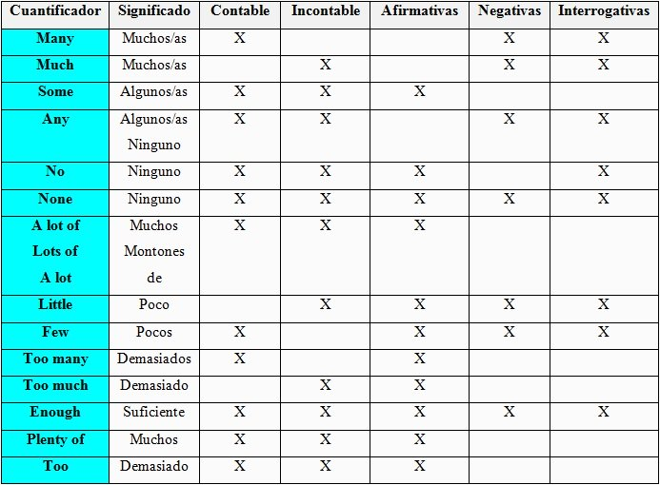

Exercises

I. - Complete the following sentences using *much, many, few, little, lots, a lot of, enough.* (Completa las oraciones con *much, many,* few,*little, lots o, a lot of*o*enough)*

1. The kids don’t get ______________ pocket money.
2. The problem is that there are too ___________________ online banks, I only know two, I need more options.
3. After my wallet was stolen, I had _____________________ problems.
4. I always receive letters from my bank, it’s too ________________________ paperwork.
5. It’s not a lot but I have already saved a _________________________ money.
6. I can’t afford a new car; I don’t have ____________________________ money yet.

II. - Complete the following sentences with *some or any.* (Complete las siguientes oraciones con *some* o *any)*

1. I don’t have _______________change for my bus ticket.
2. Oh no, have you forgotten your wallet? Would you like to borrow _____________money?
3. I’m not sure - are there __________________nice restaurants in this area?
4. I’m sorry I don’t have ___________________   cash on me.
5. There are _________________great money saving apps online.
6. I haven’t got ____________________ cash for the carpark – do you

have ___________________coins I can use?

III.- **Autoevaluación**

Leer cuidadosamente los criterios antes de autoevaluarse. Califíquese con una nota entre 1.0 (Insuficiente) a 7.0 (Muy bueno) según lo indicado.

Nombre Completo: Curso:

|  |  |  |
| --- | --- | --- |
| Criterios de Autoevaluación | Nota | Definición |
|  |  |  |
| No cumplo con lo requerido en la guía de autoaprendizaje | 1.0 a 3.9 | Insuficiente |
| Cumplo parcialmente expectativas de lo requerido en la guía de autoaprendizaje | 4.0 a 5.5 | Suficiente |
| Cumplo expectativas de lo requerido en la guía de autoaprendizaje | 5.6 a 6.5 | Bueno |
| Excedo expectativas de lo requerido en la guía de autoaprendizaje | 6.6 a 7.0 | Muy Bueno |
|  |  |  |
| Nota Autoevaluación |  |  |